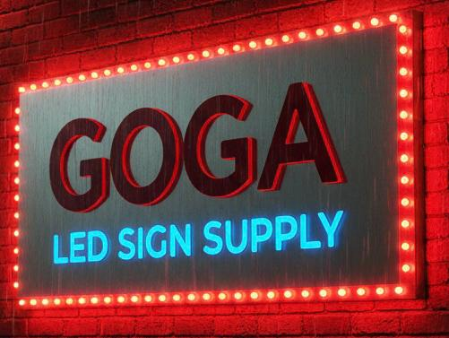

Led sign P4 outside iron cabinet, custom size program by WIFI with 2-years warranty
Good Quality full color inside & outside display video photos text messages. Plus I put messages in sign .These are excellent for any business that needs a simple, cost effective and prompt marketing tool. Our signs can be effortlessly installed with just a few screws and easy mounting ears which come with the package; programming is as simple as typing in Word. Simply install the software on to your windows computer, setup the sign, type the words you want on the computer then update it with flash drive, and there it is on the sign.
You can watch on YouTube / https://youtu.be/at7PTKYXkNQ
https://www.ledsign-supply.com/
Call 586-604-8260 / Gus

